“Working the Angles:”

Using a Gyroscope on your Robot;
A Simplified Method



Jim Zondag
Team #33 – Killer Bees
jez@dcx.com

“How can you know where to go, if you don’t know where you are?”

Abstract:
Accurate determination of heading angle is critical when attempting to make robotic vehicles pilot themselves. There are many ways that this can be done but one of the fastest and simplest is using a solid state gyroscope, also known as a yaw rate sensor.
This paper discusses the concepts behind how angle is measured, how to connect and mount your gyro-chip, and how to write software to perform the needed functions on the robot. My objective is to make all aspects of this as simple and easy to understand as possible. All unneeded complexity has been avoided. Even if you have no experience with electronics or programming you should be able to implement this feature easily.
Team #33 has successfully used this method to guide our FIRST robots since 1999 when Gyros were first added to the kit of parts. The method outlined here uses a single simple periodic function. This method is simpler and less invasive than other methods previously published.

Background:
To understand how to properly use a gyro in your system, you must first understand a little bit of Calculus (fear not, it is easy). A gyro cannot tell which direction you are facing, it can only tell you how fast you are rotating, also known as angular velocity. In order to determine heading from this information, we must Integrate the gyro data. Integration is simply summing the area under a data curve. By summing up the area under the curve, we can keep track of how far the robot has turned from its original orientation.

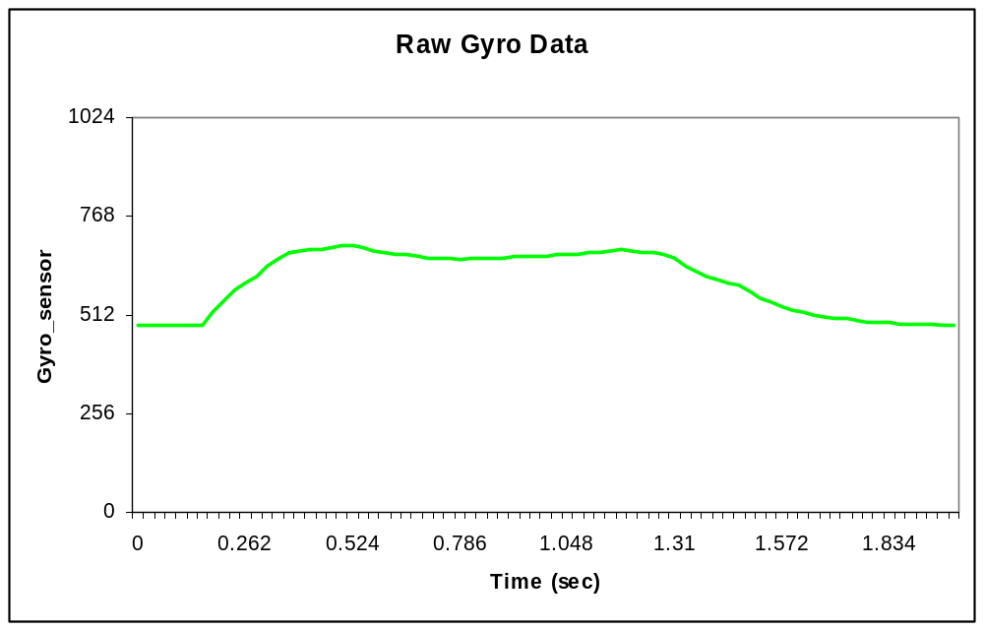
Start of
Turn
End of
Turn
Idle Voltage

Graph 1.1 - Data from 90 degree CW turn

Graph 1.1 above is a data log snapshot of a 90-degree clockwise turn event taken from Buzz10, our 2005 FIRST robot. The gyroscope will output a positive offset voltage above the idle voltage for a clockwise rotation, and a negative offset below the idle voltage for counterclockwise rotation. From the trace in Graph 1.1 you can clearly see the positive magnitude of the gyro output. The start and end of the turn are quite obvious. The next step is to do a little Calculus and perform the Integration function.

Integration is very simple in any computer that performs operations in a periodic loop. Every FRC Robot Controller processes its main control loop every 26.2 milliseconds (38.2 loops per second). 38.2 times per second, the processor executes the function Process_Data_From_Master_uP(void) or User_Autononomous_Code(void) depending upon if you are in Normal or Autonomous mode. The processor will then wait until the next loop to do it again. This timing is very well controlled because it is tied to the Radio Transmit packets. For every application I have ever done, even on very fast robots, this is a more than adequate sampling rate for gyro heading measurement and control. Using the built-in main loop timing greatly simplifies the implementation as compared to methods that use timer interrupts and can easily be implemented by novice programmers.

In the RC main loop we have a function call to a new function named gyro_angle() which computes the heading angle every 26.2 ms. Graph 2.1 below shows the individual samples as collected from the Dashboard data stream. The data is normalized to the zero point idle voltage as discussed above.

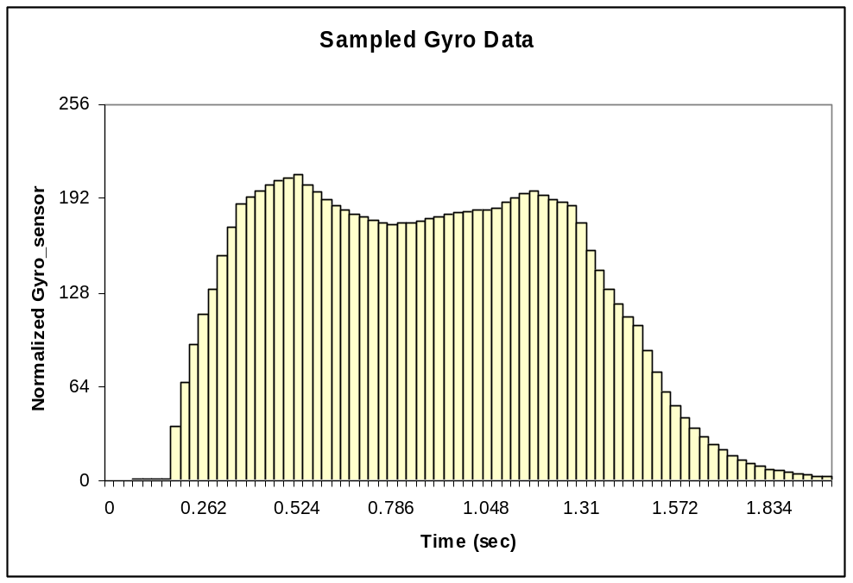

Graph 2.1 – Normalized Gyro Data samples

Now comes the easy part: All you have to do is add these samples up to keep track of your angle. Due a fortunate mathematical coincidence, the raw data output from the ADXRS150EB at this sampling rate is pretty much exactly 100-bits per degree, making it very easy to compute the heading. (ADXRS300EB = 50 bits/degree). Why 100 bits per degree? Let’s do the math (Good Engineers ALWAYS do the math!).

1. Per the ADXRS150 Data Spec the Output Sensitivity of the gyro chip is 11.25 to 13.75 mV/Degree/Second. I have 3 of them and they all test to roughly nominal at 12.7 to 12.8 mV/Degree/Second.

2. As stated earlier, the FRC main loop runs at 38.2Hz.

3. At a rotation rate of 1 degree per loop, we would thus be rotating at 38.2 degrees per second. Multiply this by the output sensitivity and you get:
38.2 ^{O}/S x 12.8 mV/ ^{O}/S = 489mV.

4. The 10 bit Analog to Digital Converter on the Robot Controller has a bit resolution of:
5.00V / 1023 = 4.89mV/Bit

5. Thus the digital input value to the CPU at 1^{O} per task loop is
489mV / 4.89mV/Bit = 100 Bits.

The gyro output is linear through its angular velocity range so we can always use this scaling.
Sweet! It is very handy that the numbers just happen to line up this way.
Graph 3.1 below is data from the sampling Graph 2.1 above simply added together as it is collected in the main loop and then divided by 100 to get the heading in degrees.
Look, A perfect 90 degree turn. It’s just that easy!

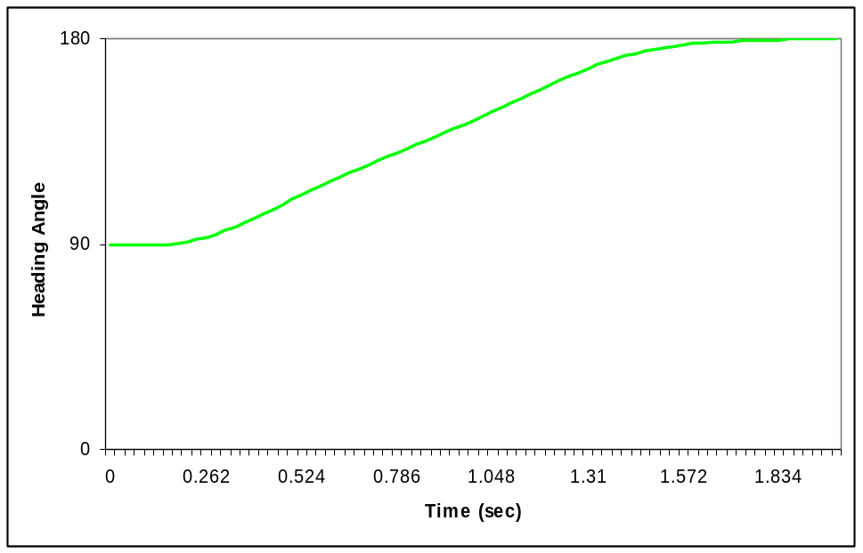

Graph 3.1 Integrated Gyro Data

Components:
The solid-state Gyros we use are either an Analog Devices ADXRS300EB or an ADXRS150EB depending on the game and speed at which robot is to move. These parts are available from Newark or Digi-Key for roughly $80 each (not cheap but well worth the price). The two parts are identical except for the output resolution. An ADXRS150EB can be used at angular velocities of up to 150 degrees per second; the ADXRS300EB can do up to 300 degrees per second. The ADXRS150EB has twice the sensitivity and thus will yield higher accuracy. You must decide for your own application which is right for you. Be sure to order the Parts with the “EB” name suffix (Evaluation Board), this is the only package version you can work with using hand soldering tools.

The Gyro Chip EB versions come in a 20 PIN Dual Inline IC Package. You will need to make a small circuit board to mount the chip on, similar to the one pictured below. I used a 20 pin DIP socket to mount the chip to avoid soldering directly to the chip itself.

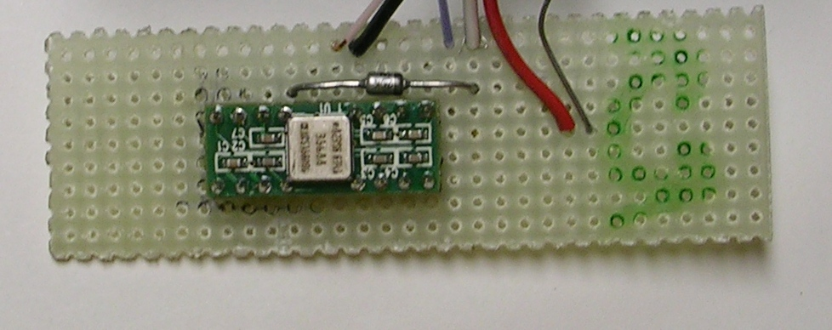
12
13
8
2
1

Picture 1.1 – GyroChip on PC board

Cut the male connector end off of a standard PWM cable and strip back the wires. Solder the Black wire (Ground) to Pins 8 and 12, Solder the Red Wire (5 volts DC) to Pins 1 and 13, and Solder the White wire (Analog signal) to Pin 2.

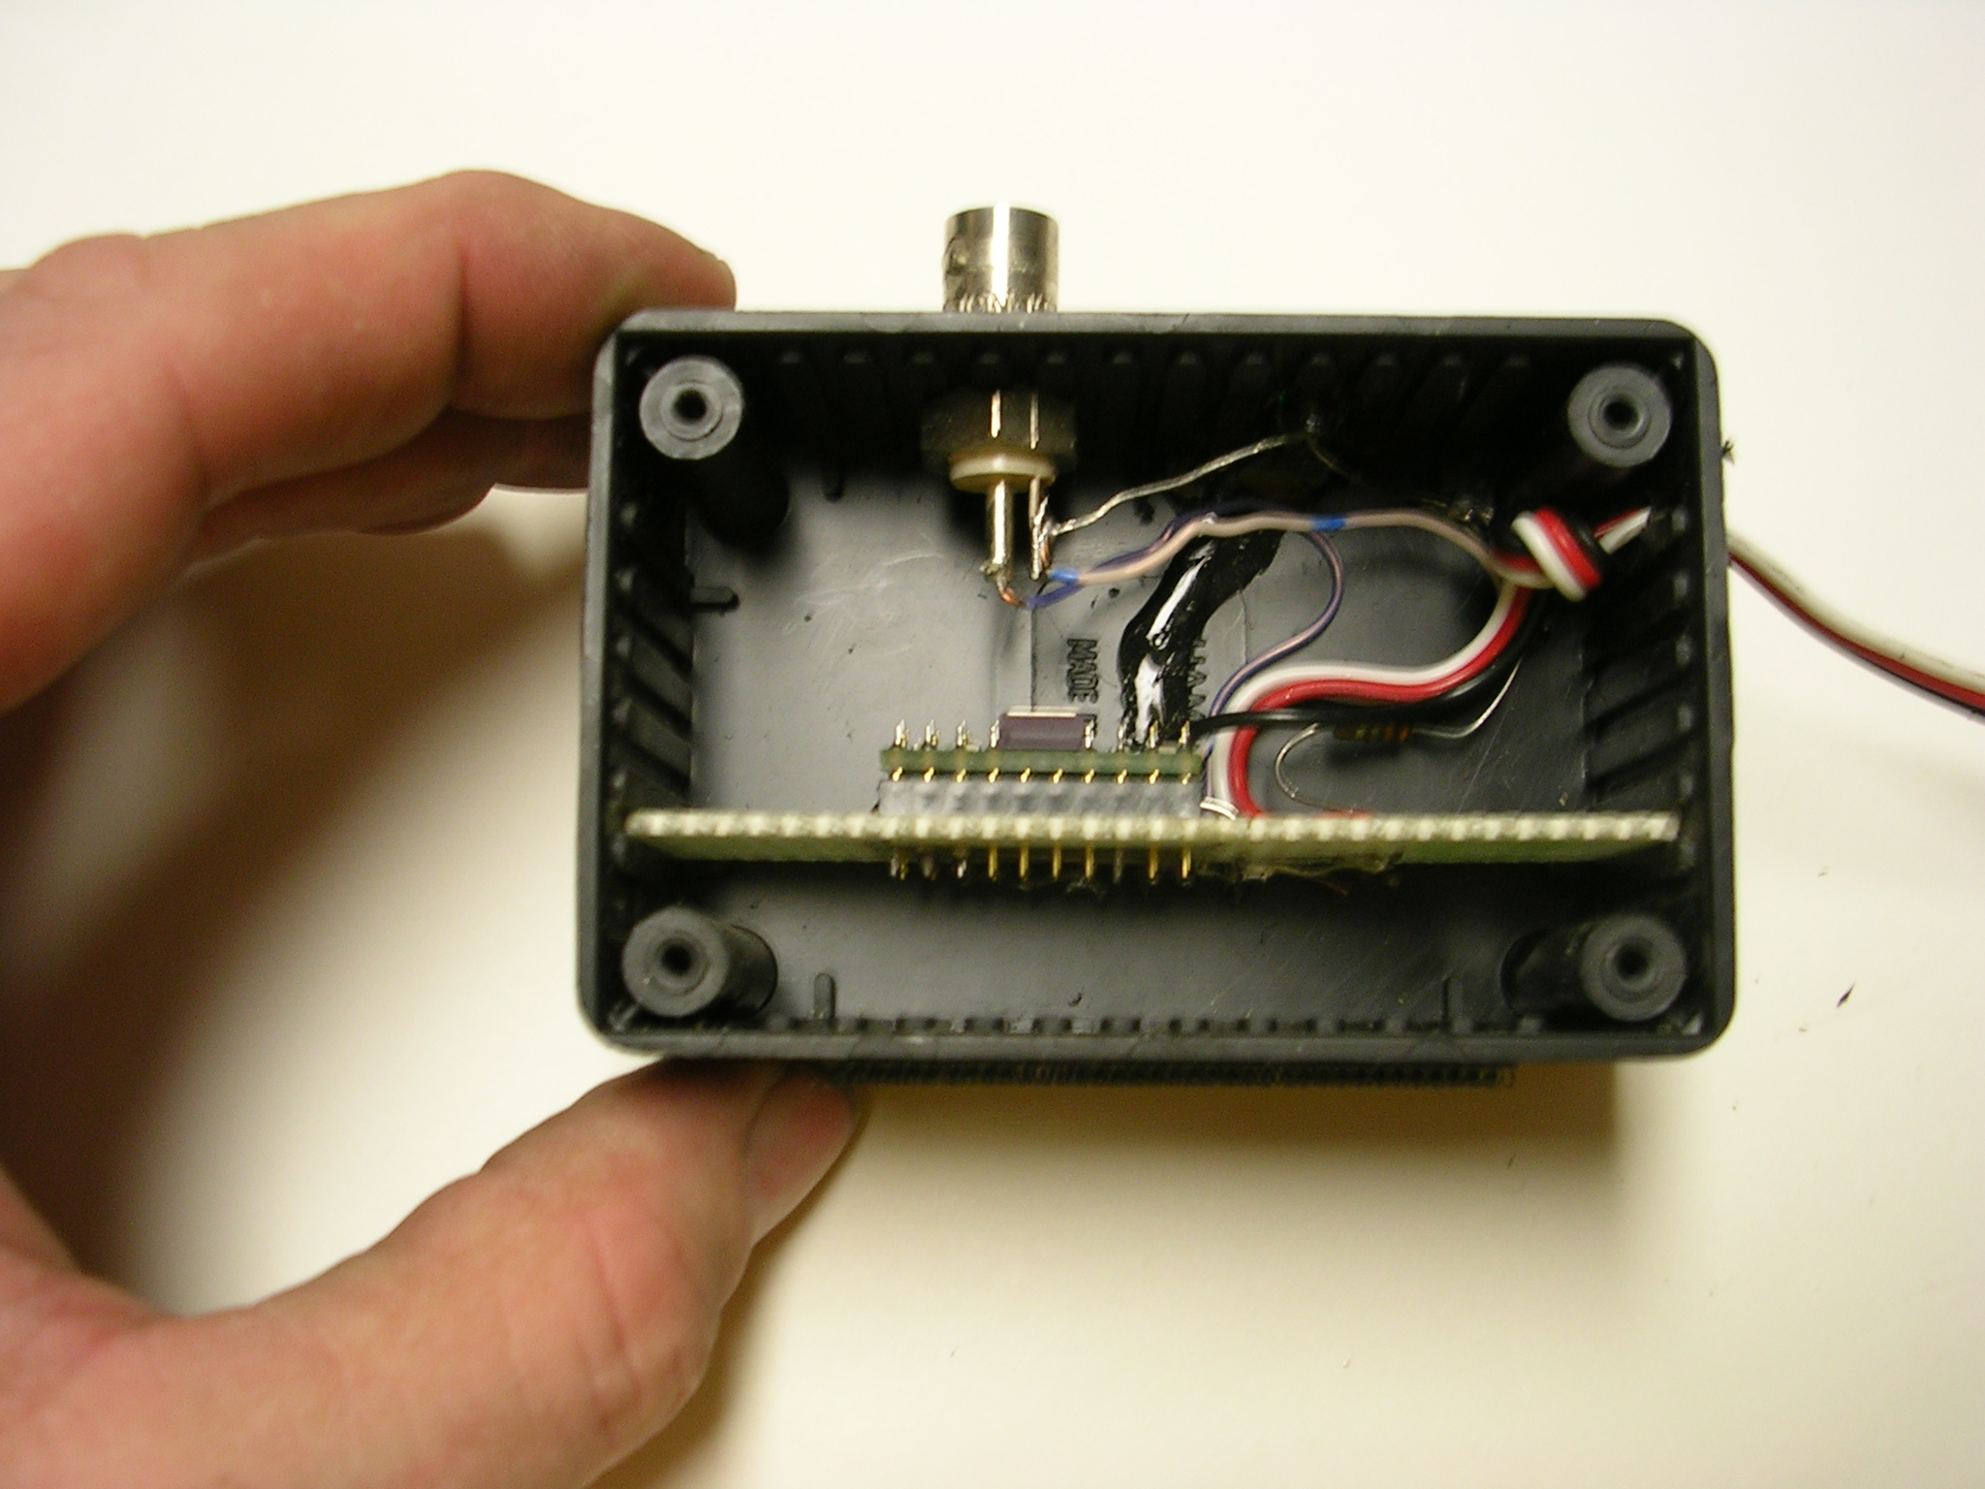
Picture 1.2 – GyroChip in Project Box

Mount the gyro in a small project box as shown above. On mine I added an LED to indicate the box has power, a BNC connector so I can easily connect an oscilloscope to the gyro output , and I put a 5.7 volt Zener diode across the 5 volt supply as a circuit protector. All of these items are optional. Below is a list of the only parts you need to build a basic gyro box:
Gyro: Digikey PN ADXRS150EB-ND or ADXRS300EB-ND
. Chip Socket: Digikey PN A9420-ND
Project Box: Digikey PN SR110-IB-ND.
Perf PCB: Digikey PN SR310-ND
To order go to www.digikey.com. Active Electronics, or Newark Electronics will also carry these materials but under different part numbers. Mine are built from stuff I found in the lab so it looks a little different than it will if you build it from the parts listed above. You can connect your gyro to any Robot Controller Analog Port. This example uses Analog Input 1 as the gyro input.

Biasing:
These gyro sensors output an analog signal from approx. 0.25 to 4.75 Volts DC. When the device is not rotating it will have an output voltage of roughly 2.5 Volts. You will need to tune this zero point for each individual gyro and Robot Controller pair that you use.
This can be done by simply checking the gyro output value while it is stationary. The debug line below will send the value of the gyro to the debug window on your PC.

printf("gyro %d\n",(int)Get_Analog_Value(rc_ana_in01));

Insert this line into your code and write down the gyro center value reported.
The gyro center zero point is typically around 480-500 counts on most implementations.
The gyro will output a voltage greater than the zero point if rotating clockwise; less that the zero point if turning counter-clockwise.

Software implementation:
Now that we’ve covered the theory, let’s get down to coding…yee haw.
The entire function is brief and is listed below. Call this function on each pass through the code every 26.2ms. Function gyro_angle() reads the value from Analog Port One and if the value is outside of the +- 2 bit noise band around the zero point, then the function will recompute the heading angle. All angles are positive, with rollover at 360 degrees managed in both directions. The function generates two global output variables: gyroangle is the heading times 100 (180 degrees = 18000), degrees is the heading angle rounded off to the nearest degree. I have included a complete version of this code in an MPLAB project file group attached to this posting. This version is derived from Kevin Watson’s FRC_encoder version posted early in the 2005 season. The gyro code, together with two wheel encoders, will give you everything you need to make a great Autonomous Mode
If you want to put this code into an existing project and you don’t feel like retyping everything, you can simply cut and paste the code from this document file directly into the MPLAB code editor. Put this function at the very bottom of file user_routines.c,or you can copy gyro.c from the attached project group into your project.

/**********************************************************************
*
* FUNCTION: gyro_angle()
*
* PURPOSE: Integrates gyro signal to keep track of robot
* heading.
*
* CALLED FROM: user_routines.c / Process_Data_From_Master_uP()
* user_routines_fast.c / User_Autononomous_Code()
*
* PARAMETERS: None
*
* RETURNS: Nothing
*
* COMMENTS: call gyro_angle() from Process_Data_From_Master_uP()
* to calculate angle from normal mode.
* call gyro_angle() from User_Autononomous_Code()
* to calculate angle from autonomous mode.
* This example uses an ADXRS150 connected to Analog01
*
**********************************************************************/
// Define Macros
#define NULL_BAND 2 // dead band about zero point
#define GYRO_CENTER 482 // zero point center of gyro,
// This MUST be tuned in each application
// Define Global variables
unsigned int gyroangle; // global of full heading in 1/100 degree
unsigned int degrees; // global of heading in Degrees
void gyro_angle(void)
{
unsigned int gyro = Get_Analog_Value(rc_ana_in01); // sensor on Analog 01
// copy A/D port value to local to prevent changes during this subroutine
if (gyro > (GYRO_CENTER + NULL_BAND)) {// Clockwise Rotation
gyro = gyro - GYRO_CENTER; // Normalize gyro signal
if ((gyroangle + gyro) > 36000) { // check for rollover at 360degrees
gyroangle = gyroangle + gyro - 36000; }
else {
gyroangle = gyroangle + gyro; }
}
else if (gyro < (GYRO_CENTER - NULL_BAND)) { // CCW Rotation
gyro = GYRO_CENTER - gyro; // Normalize gyro signal
if (gyro > gyroangle) { // check for rollover at 0 degrees
gyroangle = 36000 - gyro + gyroangle; }
else {
gyroangle = gyroangle - gyro; }
}
degrees = (gyroangle + 50) / 100; // round off to nearest degree
printf("gyro %d, degrees %d\n" ,(int) gyro,(int)degrees); // debug data
}
// end function gyro_angle()********************************************/

Once you have added the gyro_angle(void) function above, there are only four other small modifications needed to the standard FRC default code to fully support this function. Again, these are all already in the provided code, this is merely a review of the changes made.

- Add the following 3 definitions in file user_routines.h so that the definitions of the function and heading variables are visible to all files.

extern void gyro_angle(void); // gyro function prototype
extern unsigned int gyroangle; // global of full heading in 1/100 degree
extern unsigned int degrees; // global of heading in Degrees

2. Add the function call gyro_angle(); in file user_routines_fast.c, function User_Autononomous_Code(void) to compute angle in autonomous mode.

/* Add your own autonomous code here. */
gyro_angle(); // call gyro angle function every 26.2 ms

3. Add the function call gyro_angle(); in file user_routines.c, function Process_Data_From_Master_uP(void) to compute angle in normal mode.

/* Add your own code here. */
gyro_angle(); // call gyro angle function every 26.2 ms

4. If you do not wish the starting angle to be zero, you can initialize it to whatever you like in file user_routines.c, function User_Intitialization(void). You can set the angle by writing to gyroangle with the starting angle times 100 as below:

/* Add any other initialization code here. */
gyroangle = 18000; // set initial heading to 180 degrees

If you have multiple autonomous modes, you may wish to also do this in User_Autononomous_Code(void) so you can have different starting angles for each auto mode.

That’s it. Once you implement all the items above, you can then begin to use this feature on your robot. The first step is to get your robot to make a single measured, controlled turn.

Making a Turn:

There are many ways to autopilot a robot. I will use the simplest possible method below as an example of how to make a turn in an autonomous sequence.
This simple sequence executes a 90-degree turn to the left at 50% power. Starting angle is 18000 (180 degrees). Put this in code in file user_routines_fast.c, function User_Autononomous_Code(void).

/* Add your own code here. */
#define SPEED1 63 // output power to PWM == 50% = 127/2 = 63
gyro_angle(); // call gyro angle function every 26.2 ms
pwm01 = 127 - SPEED1; // spin turn pwm01 is left drive (rev)
pwm02 = 127 + SPEED1; // pwm02 is right drive (fwd)
if (gyroangle <= 9000) { // keep turning until 90.00 degrees
pwm01 = 127; // stop both motors
pwm02 = 127; }

When you switch to Auto mode, this simple piece of code will always cause your robot to turn 90 degrees to the left regardless of battery power, traction, or other uncontrolled variables. As you can easily imagine, you can expand this code to create multi-step, complex paths. One obvious limitation is that coasting past the control angle is possible in this simple example if you try to turn really fast. This can be easily eliminated with more software, but that is the topic of a future paper. Even simpler is to simply execute your turns slowly enough so that this is never a problem.

Conclusion:
This method of measuring angles, while not perfect, is more than adequate for FIRST Robotics applications. It is very easy to understand, implement and teach; key parameters for any FIRST design. Combining a gyro with a simple encoder based distance measurement systems enables you to reduce your autonomous mode sequence to a simple geometry problem. We have often developed new auto modes in the pits with a nothing more than ruler, protractor, and layout drawing of the field. With the help of this paper, you can too.

Good Luck Teams!

Jim Zondag

Team #33 – Killer Bees
o_o_o_o
./| ,[_____],
|¯¯¯L--O|||||||O
()_)¯()_) ¯¯¯ )_)

“To learn what is possible, we must attempt the impossible”
- Arthur C. Clarke

